- how to configure spark cluster step by step

ChatGPT said:
Worked for 8s

How to configure an Apache Spark cluster step by step

Since you're setting up PySpark with VS Code, let's configure a multi-node Apache Spark cluster and connect your Python code to it.
A Spark cluster lets you run distributed data processing across multiple machines instead of using only your laptop's CPU.

1. Understand the cluster architecture
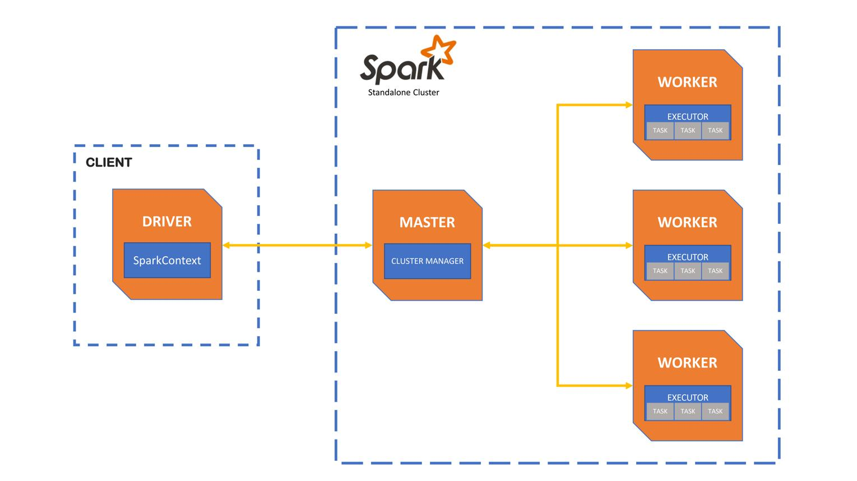

A basic Spark cluster has these components:
  - Master: Coordinates the cluster and tracks available resources.
  - Workers: Machines that provide CPU and memory for Spark applications.
  - Driver: Runs your application's main logic and coordinates execution.
  - Executors: Processes that run tasks and store data on behalf of your application.
  - VS Code machine: Where you write and submit your PySpark code.

For this tutorial, we'll use Spark Standalone mode. It's a good way to learn cluster configuration without setting up Hadoop or Kubernetes.

We’ll assume three Linux machines or virtual machines on the same private network:

Machine | Example private IP | Role
spark-master | 192.168.1.10 | Master
spark-worker-1 | 192.168.1.11 | Worker
spark-worker-2 | 192.168.1.12 | Worker
These are example IP addresses; replace them with your machines' actual addresses. You can also start with one machine and add workers later.

2. Install Java and prepare all machines
Run the setup on the master and both worker machines. The example commands below assume Ubuntu Linux.

2.1 Install prerequisites
bash
sudo apt update
sudo apt install -y openjdk-17-jdk python3 python3-pip python3-venv curl
Check Java and Python:
bash
java -version
python3 --version
All machines should have compatible Java installations, the same Spark distribution/version, and network access to each other.

2.2 Configure hostnames
On each machine, edit /etc/hosts:
bash
sudo nano /etc/hosts
Add the addresses of all three machines, using your actual private IPs:
text
192.168.1.10 spark-master
192.168.1.11 spark-worker-1
192.168.1.12 spark-worker-2
Test connectivity from each machine:
bash
ping -c 3 spark-master
ping -c 3 spark-worker-1
ping -c 3 spark-worker-2
If these tests fail, fix the network or hostname configuration before proceeding.

3. Install Apache Spark on every node
Download the same prebuilt Apache Spark distribution on the master and both workers from the official Apache Spark downloads page .
Choose a release compatible with your Java installation and download the prebuilt package. For this example, assume the extracted directory is /opt/spark.
If you download the archive into your home directory, extract it and move the resulting Spark directory to /opt/spark. Adjust the archive filename to match your download.
For example:
bash
sudo tar -xzf spark-<version>-bin-hadoop3.tgz -C /opt
sudo mv /opt/spark-<version>-bin-hadoop3 /opt/spark
Replace <version> with the version in the downloaded filename. If you use a different distribution name, adjust the directory accordingly.
Set the environment variables on each node:
bash
nano ~/.bashrc
Add:
bash
export SPARK_HOME=/opt/spark
export JAVA_HOME=/usr/lib/jvm/java-17-openjdk-amd64
export PATH=$PATH:$SPARK_HOME/bin:$SPARK_HOME/sbin
Reload the settings:
bash
source ~/.bashrc
Verify:
bash
spark-submit --version
Repeat on every node, ensuring that SPARK_HOME and JAVA_HOME point to the correct directories on that machine.

4. Start the Spark master
On spark-master, run:
bash
$SPARK_HOME/sbin/start-master.sh
The command should display a master URL similar to:
text
spark://spark-master:7077
Use the URL printed by your own master process. If it prints a different hostname or address, make sure that address is reachable from the workers and your development machine.
Open the master dashboard in a browser:
http://192.168.1.10:8080
You should see the master status and available worker information.
The default master service port is 7077, and the default master web interface port is 8080.

Spark 4.2.0 Documentation

5. Start the worker nodes
Now connect both workers to the master.
On spark-worker-1, run:
bash
$SPARK_HOME/sbin/start-worker.sh spark://spark-master:7077
On spark-worker-2, run:
bash
$SPARK_HOME/sbin/start-worker.sh spark://spark-master:7077
You can limit each worker's resources if needed. For example, to allocate four CPU cores and 4 GB of memory:
bash
$SPARK_HOME/sbin/start-worker.sh \
--cores 4 \
--memory 4G \
spark://spark-master:7077
Open the master dashboard again:
http://192.168.1.10:8080
You should see both workers registered. Their available CPU cores and memory should appear on the dashboard. If only one worker appears, check its logs and network connectivity.
Spark 4.2.0 Documentation

6. Configure network ports
The machines must be able to communicate through the required ports. For a basic setup, these include:
Port | Purpose
7077 | Master service
8080 | Master dashboard
8081 | Default worker dashboard
4040 | Application dashboard
Worker and driver ports | Executor communication and application callbacks
Worker and driver ports may be dynamically assigned unless configured otherwise. For a more controlled deployment, configure fixed ports and allow the required traffic between trusted cluster machines.
If you use a firewall, permit these ports only from the private network or trusted hosts. Do not expose Spark's unauthenticated interfaces directly to the public internet. Spark Standalone does not enable all security protections by default.
Spark 4.2.0 Documentation

7. Connect PySpark from VS Code
You can now use VS Code to write a PySpark application that submits work to the cluster.
There are two common options:
  - Recommended for your first setup: Run VS Code on the master machine, or connect to it using Remote SSH. This avoids many networking issues.
  - Run VS Code on your laptop and connect remotely. In this case, the laptop's driver must be reachable by the worker machines, not just able to reach the master.

7.1 Create the Python environment
On the machine where the Python driver will run:
bash
mkdir pyspark-client
cd pyspark-client

python3 -m venv .venv
source .venv/bin/activate

python -m pip install pyspark
Use the same PySpark version as the installed Spark distribution. Select .venv as the Python interpreter in VS Code.

7.2 Create main.py
python

from pyspark.sql import SparkSession

spark = (
SparkSession.builder
.appName("MyClusterApplication")
.master("spark://spark-master:7077")
.config("spark.cores.max", "4")
.config("spark.executor.cores", "2")
.getOrCreate()
)

print("Spark version:", spark.version)
print("Master:", spark.sparkContext.master)

data = [(i, i * i) for i in range(1, 11)]
df = spark.createDataFrame(data, ["number", "square"])

df.groupBy().sum("square").show()

print("Execution details:")
print(spark.sparkContext.statusTracker().getExecutorInfos())

spark.stop()
Run the application:
bash
python main.py
The expected sum of squares is 385.
The key setting is:
python
.master("spark://spark-master:7077")
It directs Spark to the cluster master instead of running the application entirely in local mode.
The resource settings in this example limit the application's total allocated cores and request two cores per executor. Actual executor placement depends on available worker resources.
Important: This PySpark example uses client deploy mode, meaning the Python driver runs on the machine where you launch the script. Spark Standalone's cluster deploy mode is not supported for Python applications in the same way as it is for JVM applications.
Spark 4.2.0 Documentation

8. Verify distributed execution
Once the program starts:
  - Open the master dashboard at http://192.168.1.10:8080.
  - Confirm both workers are registered.
  - Open the Spark application dashboard, normally at http://localhost:4040 on the driver machine.
  - Inspect the Jobs, Stages, Executors, and Environment tabs.
  - Check the worker logs if the application fails or no executors register.
To stop the services, run these commands on their respective machines:
On the master:
bash
$SPARK_HOME/sbin/stop-master.sh
On each worker:
bash
$SPARK_HOME/sbin/stop-worker.sh

9. Which type of Spark cluster do you want to build?
Standalone mode is a good starting point, but your best setup depends on where you intend to run Spark.
Where will you install Spark?
Windows laptop with VS Code
Ubuntu/Linux machines
Cloud virtual machines
Docker containers
What's your goal?
Learn Spark locally on one machine
Build a real multi-node cluster
Deploy a production cluster
How many machines do you have?
1 machine
2 machines
3 machines
4 or more machines

You said:
Give me a complete step-by-step Apache Spark cluster setup tailored to this environment: Windows laptop. Goal: Learn on one machine. Available machines: 3 machines. Include exact commands, configuration files, networking, VS Code integration, and verification.

ChatGPT said:

Recommended approach for your Windows laptop

Because your goal is to learn on one machine, you do not need to configure three physical machines, even though you have three available. Start a master and two workers on the same laptop, then optionally move the workers to separate machines later.
For Windows, I recommend using WSL2 (Ubuntu) for the Spark cluster and VS Code for editing. Apache Spark supports Windows, but its distributed shell scripts are designed primarily for Unix-like environments; WSL2 avoids many Windows-specific setup issues. Spark's official documentation describes Standalone as the simplest cluster manager for a private cluster.
Spark 4.2.0 Documentation
+1

Your learning environment
Windows laptop
VS Code + WSL2 Ubuntu
Spark Master
Coordinates resources · port 7077
Worker 1
Local process
Worker 2
Local process
The three Spark processes can run on your laptop using loopback networking. This is useful for learning cluster scheduling, but it is not the same as having three independent machines with separate CPU and memory.

Step 1: Install WSL2 on Windows
Open PowerShell as Administrator and run:
powershell
wsl --install -d Ubuntu
Restart Windows if prompted. Open Ubuntu from the Start menu and create your Linux username and password.
Verify that WSL2 is installed by returning to PowerShell:
powershell
wsl --list --verbose
Your Ubuntu distribution should show version 2. If it shows version 1, run:
powershell
wsl --set-version Ubuntu 2
Official guide: Install WSL .

Step 2: Install Java and Python in Ubuntu
Run these commands in the Ubuntu terminal, not PowerShell:
bash
sudo apt update
sudo apt install -y openjdk-17-jdk python3 python3-venv python3-pip curl wget
Verify the installations:
bash
java -version
python3 --version
For this tutorial, we'll use Java 17 and Python 3.10 or later with Spark 4.0.2.

Spark 4.0.2 Documentation

Step 3: Download and configure Spark
In Ubuntu, download the Spark binary distribution:
bash
cd ~
wget https://archive.apache.org/dist/spark/spark-4.0.2/spark-4.0.2-bin-hadoop3.tgz
tar -xzf spark-4.0.2-bin-hadoop3.tgz
mv spark-4.0.2-bin-hadoop3 spark
Configure environment variables:
bash
cat >> ~/.bashrc <<'EOF'
export JAVA_HOME=/usr/lib/jvm/java-17-openjdk-amd64
export SPARK_HOME=$HOME/spark
export PATH=$PATH:$SPARK_HOME/bin:$SPARK_HOME/sbin
EOF
Reload the configuration:
bash
source ~/.bashrc
Verify Spark:
bash
spark-submit --version
You should see Spark version 4.0.2.

Step 4: Start the Spark master
In the Ubuntu terminal:
bash
start-master.sh \
--host 127.0.0.1 \
--port 7077 \
--webui-port 8080
Open this URL in your Windows browser:
http://localhost:8080
The dashboard should display the Spark master.
Your master URL is:
text
spark://127.0.0.1:7077
Using 127.0.0.1 deliberately restricts this learning cluster to the same WSL environment. It is not the address to use for a cluster spanning other computers.

Step 5: Start two workers on the same laptop
Open two additional Ubuntu terminals. You can also run the commands in the original terminal after the master has started.
In the first terminal, start Worker 1:
bash
start-worker.sh \
--host 127.0.0.1 \
--port 7078 \
--webui-port 8081 \
--cores 2 \
--memory 1G \
spark://127.0.0.1:7077
In the second terminal, start Worker 2:
bash
start-worker.sh \
--host 127.0.0.1 \
--port 7079 \
--webui-port 8082 \
--cores 2 \
--memory 1G \
spark://127.0.0.1:7077
These commands use separate service and dashboard ports so the workers can coexist on one machine.
Check the master dashboard again:
http://localhost:8080
You should see two registered workers. Each worker is configured to offer two CPU cores and 1 GB of memory.
If your laptop has limited RAM, reduce worker resources accordingly. The two workers share the same physical memory and CPU, so do not allocate more resources than your laptop can comfortably support.

Step 6: Connect VS Code to Ubuntu
Install these extensions in VS Code:
  - Python by Microsoft
  - WSL by Microsoft
Then:
  - Open VS Code.
  - Press Ctrl+Shift+P.
  - Run WSL: Connect to WSL.
  - Open your Linux home directory as a project folder.
Create a project and virtual environment in Ubuntu:
bash
mkdir -p ~/pyspark-cluster
cd ~/pyspark-cluster

python3 -m venv .venv
source .venv/bin/activate

python -m pip install pyspark==4.0.2
Keep your Python client version aligned with your Spark cluster version.

Step 7: Create a PySpark application
Create main.py in VS Code and paste this code:
python

from pyspark.sql import SparkSession
from pyspark.sql.functions import sum as spark_sum

spark = (
SparkSession.builder
.appName("LocalMultiWorkerLearning")
.master("spark://127.0.0.1:7077")
.config("spark.cores.max", "4")
.config("spark.executor.cores", "1")
.config("spark.executor.memory", "512m")
.getOrCreate()
)

sc = spark.sparkContext

print("Spark version:", spark.version)
print("Master:", sc.master)

# Create a distributed dataset with multiple partitions
numbers = sc.parallelize(range(1, 100001), 8)

# Perform distributed computation
result = numbers.map(lambda x: x * x).sum()

print("Sum of squares:", result)

# Inspect executor information
for executor in sc.statusTracker().getExecutorInfos():
print(executor)

spark.stop()
Run it from the VS Code terminal, with the virtual environment activated:
bash
python main.py
Expected result:
text
Spark version: 4.0.2
Master: spark://127.0.0.1:7077
Sum of squares: 333338333350000
You should also see executor information in the terminal.

Step 8: Verify the cluster is actually being used
Do not rely only on the Python output. Check these three places:
Master dashboard
Open localhost:8080
Verify that both workers are alive and registered.
Application dashboard
Open localhost:4040
While the Python application is running, inspect its Jobs, Stages and Executors. The dashboard normally disappears when the application stops.
Worker processes
In Ubuntu, run:
bash
jps
You should see Spark master and worker Java processes, along with other Java processes that may be running.
The spark.cores.max and spark.executor.cores settings limit and shape the application's resource allocation. Spark may combine tasks into fewer executors than you expect, depending on worker resources and scheduling.

Step 9: Troubleshooting
Problem | Fix
Master URL refuses connections | Run jps and confirm the master is running.
Workers do not appear | Confirm they were started with spark://127.0.0.1:7077.
JAVA_HOME error | Run echo $JAVA_HOME and verify Java 17 is installed.
No module named pyspark | Activate .venv and install pyspark==4.0.2 again.
Application cannot connect to the master | Run the application from the same WSL environment, not native Windows Python.
Out-of-memory errors | Reduce worker memory, executor memory, or the number of concurrent tasks.

Step 10: Stop the cluster when finished
Run these commands in Ubuntu:
bash
stop-worker.sh
stop-master.sh
stop-worker.sh stops the workers on this machine; you do not need to stop each worker individually.
When you're ready to practise on your three separate machines, you can reuse the same Spark distribution and configuration concepts but replace the loopback address with the master's private network IP, configure networking between the machines, and run one or more workers on each host.
Official references
  - Apache Spark Standalone deployment
  - Apache Spark installation and requirements
  - VS Code with WSL

